BUSINESS DIRECTORY FORM

Please read this before filling out the form
To ensure a professional look of our directory, we ask you to use this form to update and submit your company and personal information.
Please note:

- The company description is limited to 1,500 characters (including spaces), Chinese or English.
- All logos need to be either vector files (Adobe Illustrator or similar) or large, high-quality Photoshop files with a transparent background.
- Please submit a suitable portrait photo with a white background, and make sure there is enough space around the head. All photos need to be print resolution (300 dpi) and a minimum of 600 x 800 pixels. We cannot place more than one photo. Kindly do not submit group portraits or holiday snapshots. See below for details.
- The space at the top of the directory page is limited. If you need more lines for additional contact information or addresses, please put them at the end of your company description.

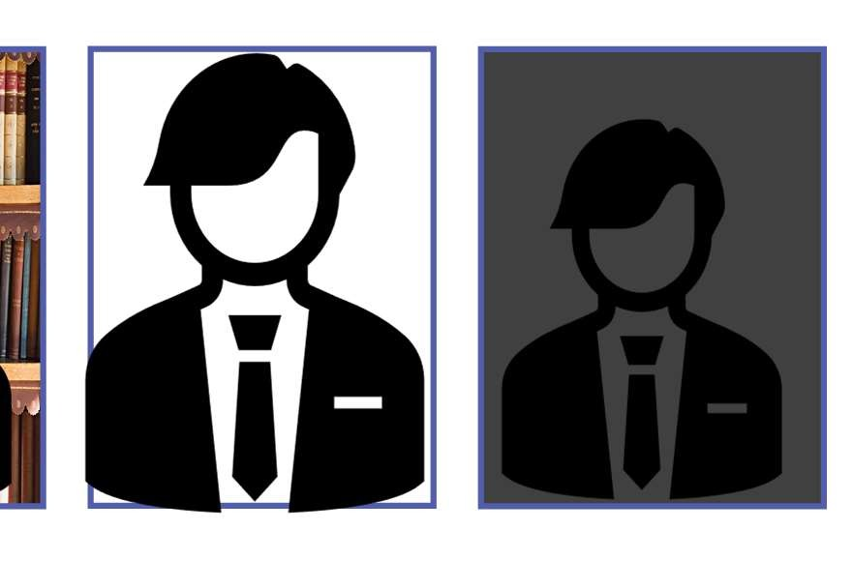Good. Proper spacing, white background
Bad: cluttered background
Bad: too cramped, not enough space
Bad: dark background

BUSINESS DIRECTORY FORM

COMPANY NAME | Company name
CHINESE COMPANY NAME (IF APPLICABLE) | Chinese company name
BRANCH OR TAG LINE  ADDRESS LINE 1 | Chinese company name
 | Chinese company name
ADDRESS LINE 2  ADDRESS LINE 3 | Chinese company name
 | Chinese company name
ADDRESS LINE 4 | Chinese company name
TELEPHONE 1 | Chinese company name
TELEPHONE 2 | Chinese company name
FAX | Chinese company name
WEB ADDRESS 1 | Chinese company name
WEB ADDRESS 2  EMAIL 1 | Chinese company name
 | Chinese company name
EMAIL 2  BUSINESS SECTOR (ENGLISH)  Refer to the category list on Page 3 | Chinese company name
 | Chinese company name
BUSINESS SECTOR (CHINESE) | Chinese company name
FIRST NAME (ENGLISH) | Chinese company name
LAST NAME (ENGLISH) | Chinese company name
CHINESE NAME  JOB TITLE ENGLISH | Chinese Name
 | Job Title English
JOB TITLE CHINESE | Job Title Chinese

BUSINESS DIRECTORY FORM

DESCRIPTION
Maximum of 1500 characters, including spaces.
Please put Chinese text and/or additional contact information at the bottom.
Kindly do not exceed the maximum number.

Business Sector:
Please Check Out Up To 3 Items To Indicate Your Business Sector 請至多選三項 :
Accounting | Construction | Government | Real Estate
Aeronautics | Consulting | Healthcare | Recruiting
AgroFood | Consumer Goods | Industry | Retail
Apparel | Education | Information Systems | Shipping & Logistics
Architecture | Electronics | Insurance | Software
Art/Design | Energy – Oil & Gas | Law | Technology
Banking | Engineering | Machinery | Telecommunications
Beauty Products | Entertainment, Restaurants | Manufacturing | Travel
Biotechnology | Environmental | Media | Wine & Spirits
Chemicals | Finance | Non Profit | Luxury goods
Communications,  Advertising, PR | Engineering | Other Professional  Services : | Other :

